**Part A**

**What will the following commands do?**

1. echo "Hello, World!"   
   **Answer**: - The above print the “Hello, World!”
2. name="Productive"   
   **Answer:-**It is not a command but it is variable in shell name and assign value “Productive”
3. touch file.txt   
   **Answer:-** This command creates a file (file.txt).
4. ls -a   
   **Answer**:- This command show the hidden, present file and directory
5. rm file.txt   
   **Answer: -**This commands remove the file in directory
6. cp file1.txt file2.txt   
   **Answer:** This command copy file content source file to destination file (like in file1.txt to file2.txt )
7. mv file.txt /path/to/directory/   
   **Answer:-**  This command mv file to destination folder or location  
   Like file.txt move in path/to/directory/ this location.
8. chmod 755 script.sh   
   **Answer:-** This command give   
   read,write,execute permission to owner,  
   read and execute permission to group,  
   read and execute permission to other user   
   For file script.txt
9. grep "pattern" file.txt   
   **Answer:-** This command finds the word between file.txt.
10. kill PID   
    **Answer:-** This command terminate the process for that need the process id
11. mkdir mydir && cd mydir && touch file.txt && echo "Hello, World!" > file.txt && cat file.txt

**Answer:-** This command create the mydir directory then enter to it and create the file file.txt after that write the content the Hello World in it and last display the content of file

1. ls -l | grep ".txt"   
   **Answer:-** The command show all the details of .txt file like permissions, user, parent directory, size , date that it create and file name
2. cat file1.txt file2.txt | sort | uniq  
   **Answer:-**  This command concatenates file1.txt and file2.txt, sorts the combined lines, and removes duplicate lines
3. ls -l | grep "^d"  
   **Answer:-** This command display the details of all directory in give present directory
4. grep -r "pattern" /path/to/directory/  
   **Answer:-**  This command show the word Mention in given “ “ in given destination path
5. cat file1.txt file2.txt | sort | uniq –d   
   **Answer:-** this command not show any output
6. chmod 644 file.txt   
   **Answer:-**  This command give some permission to file.txt file like  
   Read , write to owner,  
   Read for group  
   Read for other user
7. cp -r source_directory destination_directory   
   **Answer:-** This command copy content of one file into another
8. find /path/to/search -name "*.txt"   
   **Answer:-** This command search the .txt file in provide directory
9. chmod u+x file.txt   
   **Answer:-** This command give execute permission to user for file.txt
10. echo $PATH

**Answer:-** This command display the current value of the PATH environment variable

*********************************************************************************************************

**Part B**

**Identify the Incorrect Commands:**  
1. chmodx is used to change file permissions.   
**Answer:- false**Because the chmod is actual command and the to uses x need the adding or removing mode  
The correct command is to ( chmod +x filename )  
2. cpy is used to copy files and directories.   
**Answer:-false**Because the correct command is cp

3. mkfile is used to create a new file.   
**Answer:-false**Mkfile is not command

4. catx is used to concatenate files.   
**Answer:- false**Catx is not command

5. rn is used to rename files.   
**Answer:- false** rn is not command  
  
6. chmod 755 file.txt gives read, write, and execute permissions to the owner, and read and execute permissions to group and others.

**Answer:- true**

7. mkdir -p directory1/directory2 creates nested directories, creating directory2 inside directory1 if directory1 does not exist.  
**Answer:- true**

8. rm -rf file.txt deletes a file forcefully without confirmation.   
**Answer:- true**

**\*\*\*\*\*\*\*\*\*\*\*\*\*\*\*\*\*\*\*\*\*\*\*\*\*\*\*\*\*\*\*\*\*\*\*\*\*\*\*\*\*\*\*\*\*\*\*\*\*\*\*\*\*\*\*\*\*\*\*\*\*\*\*\*\*\*\*\*\*\*\*\*\*\*\*\*\*\*\*\*\*\*\*\*\*\*\*\*\*\*\*\*\*\*\*\*\*\*\*\*\*\*\*\*\*\*\*  
 Part C**

Question 1: Write a shell script that prints "Hello, World!" to the terminal.   


Question 2: Declare a variable named "name" and assign the value "CDAC Mumbai" to it. Print the value of the variable.

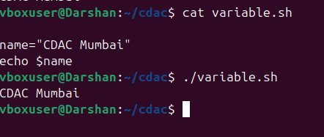

Question 3: Write a shell script that takes a number as input from the user and prints it.   
  
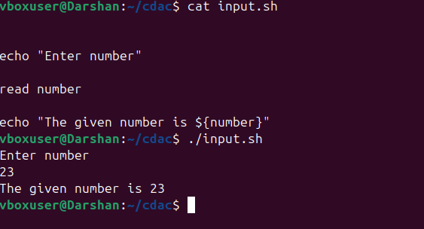  
  
  
Question 4: Write a shell script that performs addition of two numbers (e.g., 5 and 3) and prints the result.   
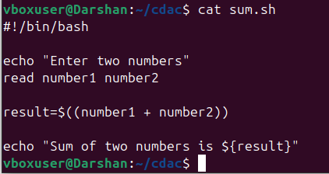

Question 5: Write a shell script that takes a number as input and prints "Even" if it is even, otherwise prints "Odd".   
  
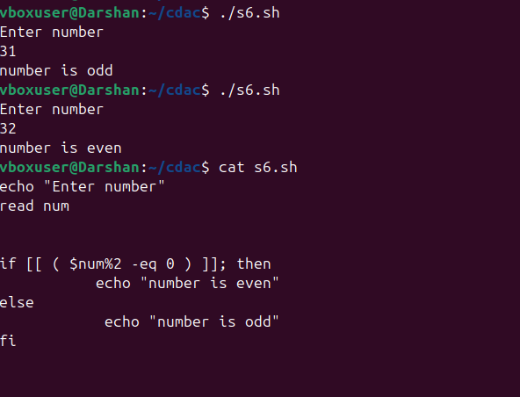  
  
  
Question 6: Write a shell script that uses a for loop to print numbers from 1 to 5.   
  
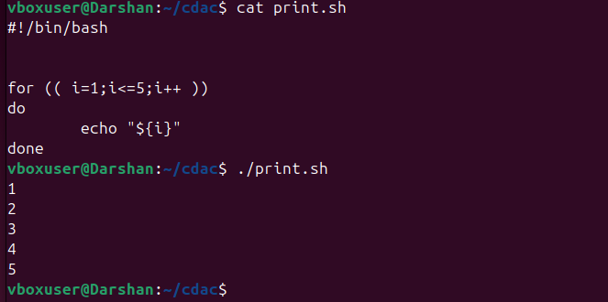Question 7: Write a shell script that uses a while loop to print numbers from 1 to 5.

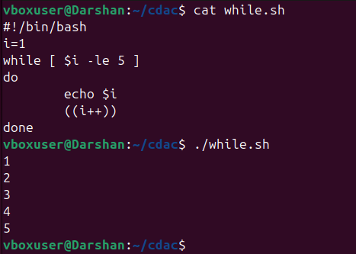

Question 8: Write a shell script that checks if a file named "file.txt" exists in the current directory. If it does, print "File exists", otherwise, print "File does not exist".

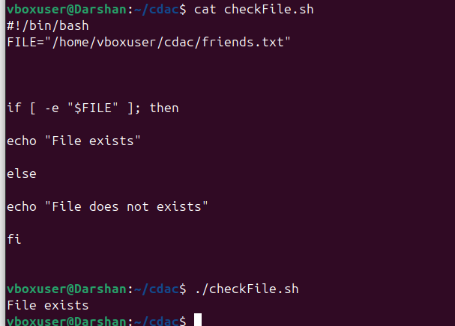

Question 9: Write a shell script that uses the if statement to check if a number is greater than 10 and prints a message accordingly.



Question 10: Write a shell script that uses nested for loops to print a multiplication table for numbers from 1 to 5. The output should be formatted nicely, with each row representing a number and each column representing the multiplication result for that number.

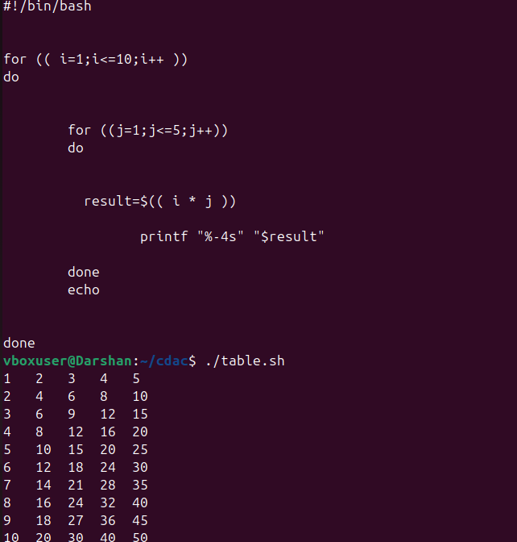  
  
  
  
  
  
  
  
  
  
  
Question 11: Write a shell script that uses a while loop to read numbers from the user until the user enters a negative number. For each positive number entered, print its square. Use the break statement to exit the loop when a negative number is entered.

-

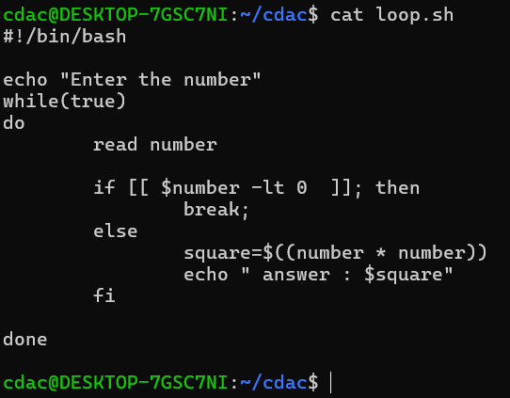

***********************************************************************************************************

**Part E**

1. Consider the following processes with arrival times and burst times:

| Process | Arrival Time | Burst Time |  
|------------|------------------|----------------|   
| P1 | 0 | 5 |   
| P2 | 1 | 3 |  
| P3 | 2 | 6 |   
  
Calculate the average waiting time using First-Come, First-Served (FCFS) scheduling.

**Answer:-**  
  
| Process | Arrival Time | Burst Time | TAT | WT |  
|------------|------------------|----------------|------------|------------ |  
| P1 | 0 | 5 | 5 | 0 |  
| P2 | 1 | 3 | 8 | 4 |  
| P3 | 2 | 6 | 14 | 6 |  
  
The Average Turn Around Time is :- 8ms  
The Waiting Time is 3.33ms

2. Consider the following processes with arrival times and burst times:

| Process | Arrival Time | Burst Time |

|---------|--------------|------------|

| P1 | 0 | 3 |

| P2 | 1 | 5 |

| P3 | 2 | 1 |

| P4 | 3 | 4 |

Calculate the average turnaround time using Shortest Job First (SJF) scheduling.   
  
**Answer:-**    
| Process | Arrival Time | Burst Time | TAT | WT |  
|------------|------------------|----------------|------------|------------ |  
| P1 | 0 | 3 | 3 | 0 |  
| P2 | 1 | 5 | 12 | 5 |  
| P3 | 2 | 1 | 2 | 1 |

| P4 | 3 | 4 | 5 | 1 |

The Average Turn Around Time is :- 5.5ms  
The Waiting Time is 2.25ms

3. Consider the following processes with arrival times, burst times, and priorities (lower number indicates higher priority):

| Process | Arrival Time | Burst Time | Priority |

|-------------|------------------|----------------|-----------|

| P1 | 0 | 6 | 3 |

| P2 | 1 | 4 | 1 |

| P3 | 2 | 7 | 4 |

| P4 | 3 | 2 | 2 |

Calculate the average waiting time using Priority Scheduling.   
  
  
  
  
  
  
  
  
**Answer:-**   
  
 | Process | Arrival Time | Burst Time | Priority | TAT | WT |

|-------------|------------------|----------------|-----------| —-------- |----------- |

| P1 | 0 | 6 | 3 | 6 | 0 |

| P2 | 1 | 4 | 1 | 9 | 5 |

| P3 | 2 | 7 | 4 | 17 | 7 |

| P4 | 3 | 2 | 2 | 9 | 10 |

The Average Turn Around Time is :- 10.25ms  
The Waiting Time is:- 5.5ms

4. Consider the following processes with arrival times and burst times, and the time quantum for Round Robin scheduling is 2 units:

| Process | Arrival Time | Burst Time |

|-------------|-----------------|----------------|

| P1 | 0 | 4 |

| P2 | 1 | 5 |

| P3 | 2 | 2 |

| P4 | 3 | 3 |

Calculate the average turnaround time using Round Robin scheduling.   
  
**Answer:-**| Process | Arrival Time | Burst Time | CT | TAT | WT |

|-------------|-----------------|----------------| —--------|------------|----------|

| P1 | 0 | 4 | 8 | 8 | 6 |

| P2 | 1 | 5 | 14 | 13 | 8 |

| P3 | 2 | 2 | 6 | 4 | 2 |

| P4 | 3 | 3 | 13 | 10 | 7 |  
  
  
The Average Turn Around Time is :- 8.75ms  
The Waiting Time is :- 5.25ms